**FRIENDS OF THE EARTH INTERNATIONAL AND JORDEN VÄNNERS-UPPSALA**

**WARMLY WELCOME YOU TO CELEBRATE**

**UPPSALA GLOBAL DAY OF ACTION FOR CLIMATE JUSTICE**

**14th OCTOBER 2017**

Azril Bacal from Friends of the Earth-Uppsala talks about the **Sustainable Agro-Ecological and Energy-Smart Bio-Farm “Casa Blanca”** in Peru.

The talk will be 30 minutes long, followed by a dialogue with the audience - and additionally with participants in an ad-hoc virtual space of the Extended World Social Forum supported by Pierre George in Paris. The question raised is how each and all of us can contribute to a sustainable, democratic and just society.

Casa Blanca is a showcase of **sustainable rural human development**. It shows that it is possible to have food security and sovereignty through healthy crops and healthy soil. Casa Blanca is not merely a farm. It is self-supporting in energy production. It is also a living educational museum. Carmen Felipe-Morales and Ulises Moreno started this farm over 30 years ago in Pachacamac, Lurin Valley, South of Lima.

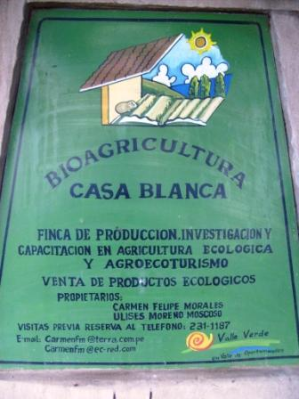 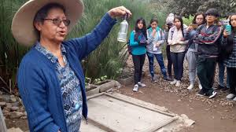

PLACE: KOLLABORATORIET, Östra Ågatan 19, Uppsala (Ground Floor)

DATE: SATURDAY 14TH OCTOBER, 2017

TIME: 13.00 – 15.00

Co-Organizers: För. AGNI, Ekilibria, Studiefrämjandet (?)