FRIENDS OF THE EARTH INTERNATIONAL AND JORDEN VÄNNERS-UPPSALA
WARMLY WELCOME YOU TO CELEBRATE
UPPSALA GLOBAL DAY OF ACTION FOR CLIMATE JUSTICE
SATURDAY 14th OCTOBER 2017
Azril Bacal from Friends of the Earth-Uppsala talks about the Sustainable Agro-Ecological and Energy-Smart Bio-Farm “Casa Blanca” in Peru. The talk will be 30 minutes long, followed by a dialogue with the audience - and with participants in a virtual space of the Extended World Social Forum (skype room 402 that may be entered via the link: https://join.skype.com/hBiYnntGPPg2). The question raised at the GDA is: How can each of us contribute in daily action to build a sustainable, democratic society - as the material base of a culture of justice, peace and solidarity? Casa Blanca is a showcase of sustainable rural human development. It shows that it is possible to have food security and sovereignty through healthy crops and healthy soil. Casa Blanca is not merely a farm. It is self-supporting in energy production. It is also a living educational museum. Carmen Felipe-Morales and Ulises Moreno started this farm over 30 years ago in Pachacamac, Lurin Valley, South of Lima.
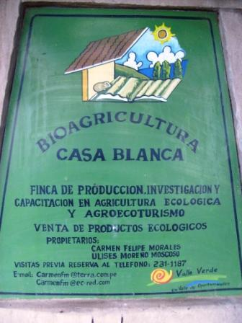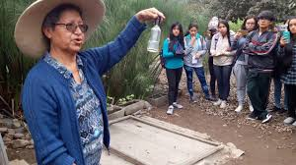
PLACE: KOLLABORATORIET, Östra Ågatan 19, Uppsala (Ground Floor)
DATE: SATURDAY 14TH OCTOBER, 2017 TIME: 13.00 – 15.00
Co-Organizers: För. AGNI, Ekilibria, Studiefrämjandet.
FRIENDS OF THE EARTH INTERNATIONAL IS A MEMBER OF THE WORLD SOCIAL FORUM. AGNI historically supported Uppsala Social Forum. Ekilibria is a local student organization promoting sustainable development. Studiefrämjandet is a Swedish association engaged with popular education and a partner of Friends of Earth-Sweden.

