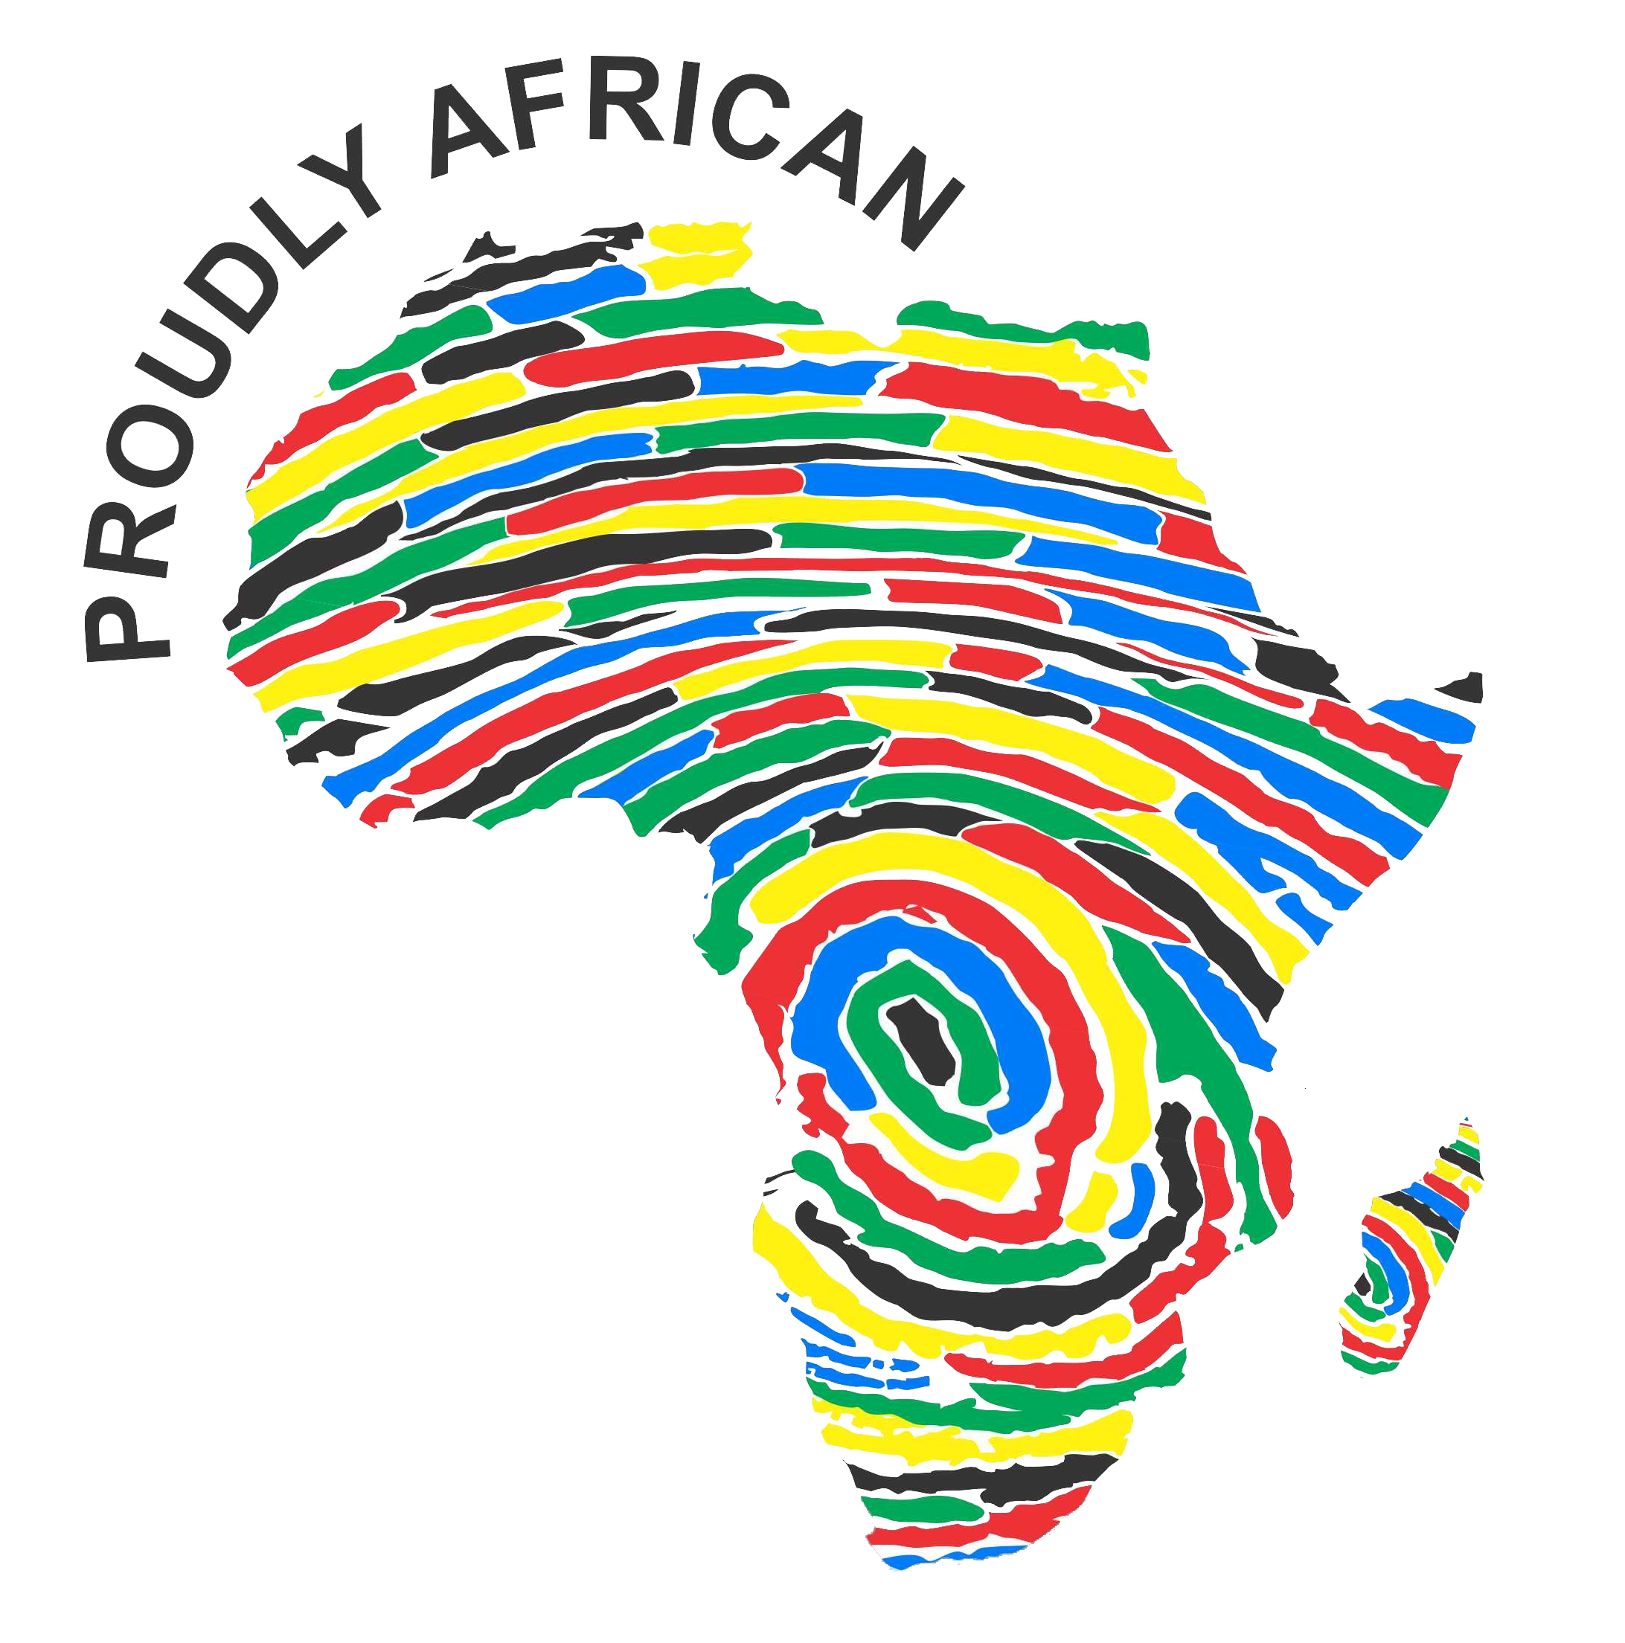

The African Solidarity Caravan at the World Social Forum in Tunisia
Join Us for in-depth discussions, reflections and strategising on key African challenges and opportunities for deepening Pan-African People-to-People Solidarity!

We kindly invite you to be part of an exciting and empowering African Solidarity Caravan discussion session during World Social forum taking place in Tunis, Tunisia from 26-30 March 2015. The African Solidarity Caravan offers activists across Africa an opportunity to reflect, connect, stragetise, organise, mobilise, transform, consolidate, and celebrate in a way that contributes to a deepened culture of Pan-African People-to-People Solidarity, African Renaissance and Pan-Africanism, Effective Organising and Mobilising for Change and a deepened Conflict Transformation approach to addressing Africa’s conflict.
The session seeks to ignite exchange and implementation of creative and innovative knowledge, ideas, skills and experience that effectively address Africa’s challenges.
Through this, we hope to deepen the connections between leaders at all levels and conflict transformation, peace building and solidarity activist throughout Africa and the rest of the world. Therefore, this invitation is extended to everybody, including Africans across the continent and in the Diaspora and all people around the world committed to the vision of a world of Justice and peace in which all the basic needs of people are met and people’s rights and dignity are respected to come and add value to the discussions.
Through our experience in Tunis, we intend to:
- Build and strengthen a strong movement for peace and Justice that will further support local initiatives for transformation across Africa.
- Learn and empower grassroots activist through the sharing of personal and collective stories of transformation.
- Share ideas and knowledge with the purpose of learning from one another and strengthening a collective African transformation agenda.
- Contribute to a shared Pan-African culture of People –to- People Solidarity.
For more information please contact:
Philani Ndebele, Campaigns Manager, ACTION Support Centre, philani@asc.org.za
+ 27 (0) 11482 2484
Website: www.proudlyafrican.mobi
Facebook: www.facebook.com/ProudlyAfriCanCampaign
Twitter: @ProudlyAfricanC

Or Gershom Kabaso Jr, National Coordinator, Zambia Social Forum (ZAMSOF)
+260 977 46 72 86 / + 260 950 721122 gersheek@gmail.com
Website http://openfsm.net/projects/zamsof/project-home

