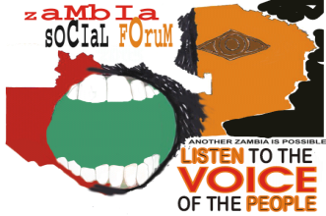

#SwazilandDemocracyCampaign, #ReleaseAllDetainees, #UbanTUCOSWA
The African Solidarity Caravan in Support of the Release Swazi Detainees and unbanning of TUCOSWA

Release of Swazi Political Prisoners and unbanning of TUCOSWA

The ACTION Support Centre (ASC) through its initiatives, the African Solidarity Caravan and the Proudly African Campaign, its partners and its support to the Swaziland Democracy Campaign joins all progressive forces in calling for the Release of Political and Civil Rights Prisoners and unbanning of TUCOSWA.

We supportthe Global Coalition for the Release of Swazi Political and Civil Rights Prisoners; targeting the immediate release of PUDEMO President Mario Masuku, Human Rights Lawyer Thulani Maseko, SWAYOCO Secretary General Maxwell Dlamini, Nation Magazine Editor Bheki Makhubu, MK and ANC cadre Amos Mbedzi and PUDEMO stalwart Zonke Dlamini.

This also includesthe unbanning of TUCOSWA and rights of workers to organise freely in Swaziland.

The ASC and its partners are seeking to collect 10 million signatures from across Africa as well as from around the world. We therefore invite you to join and support the campaign and sign this petition in order to accelerate the freedom of the people on Swaziland.

 | NAME | COUNTRY | EMAIL ADDRESS | SGINATURE
1
2
3
4
5
6
7
8
9
10
11
12
13
14
15
16
17
18
19
20
21
22
23
24
25
26
27
28
29
30
31
32
33
34
35
36
37
38
39
40
41
42
43
44
45
46
46
47
48

